

|  |
| --- |
|  |

**Jenkins Installation and Configuration**

**Guide**

# Table of Contents

!Unexpected End of Formula

1. Introduction 3

2. prerequiste 3

3. installation and configuration 4

3.1 **Jenkins Installation** 4

3.2 **Jenkins Configuration** 5

3.3 **plugin installation** 7

3.4  **Build configuration** 9

3.4.1 Adding your first job………………………………………………………………………………….9

3.4.2 Schedule your job……………………………………………………………………………………11

3.4.3 Reports on Jenkins…………………………………………………………………………………..13

# 

# Introduction

[Jenkins](http://jenkins-ci.org/) is an "extensible continuous integration server". It monitors repeated executions of jobs, such as building software projects, and can be used to build WebObjects applications and frameworks. Jenkins is an open source project and can be used at no cost

# prerequiste

**Java**

You will need to install a Java Development Kit (JDK) on your operating system .

**Git**

Git is a free and open source distributed version control system designed to handle everything from small to very large projects with speed and efficiency.

**GitLab**

GitLab offers git repository management, code reviews, issue tracking, activity feeds and wikis. GitLab is similar to [GitHub](http://en.wikipedia.org/wiki/GitHub), but GitLab has an open source version, unlike GitHub.

# installation and configuration

## **jENKINS installation**

* Before we can install Jenkins, we have to add the key and source list to apt. This is done in 2 steps, first we'll add the key.

wget -q -O - http://pkg.jenkins-ci.org/debian/jenkins-ci.org.key | apt-key add -

* Secondly, we'll create a sources list for Jenkins.

echo deb http://pkg.jenkins-ci.org/debian binary/ > /etc/apt/sources.list.d/jenkins.list

* Now, we only have to update apt's cache before we can install Jenkins.

apt-get update

* As the cache has been updated we can proceed installing Jenkins. Note that Jenkins has a big bunch of dependencies, so it might take a few moments to install them all.

apt-get install Jenkins

## jenkins Configuration

**Now that Jenkins is running, go to ci.company.net:8080. You'll be welcomed by the default Jenkins screen.**

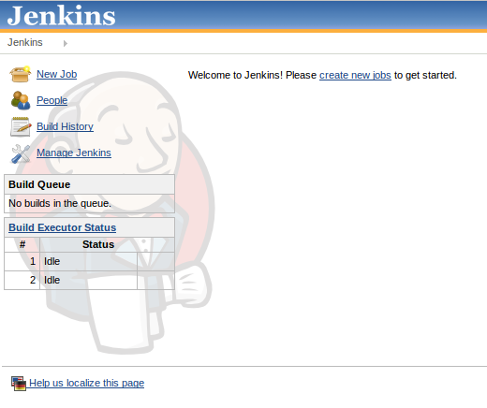

### 3.2.1. CONFIGURATION OF JOB

Before using Jenkins you need to tell it where your JDK and ant installation is. Open Jenkins in your browser and click *Manage Jenkins* and then *Configure System*.

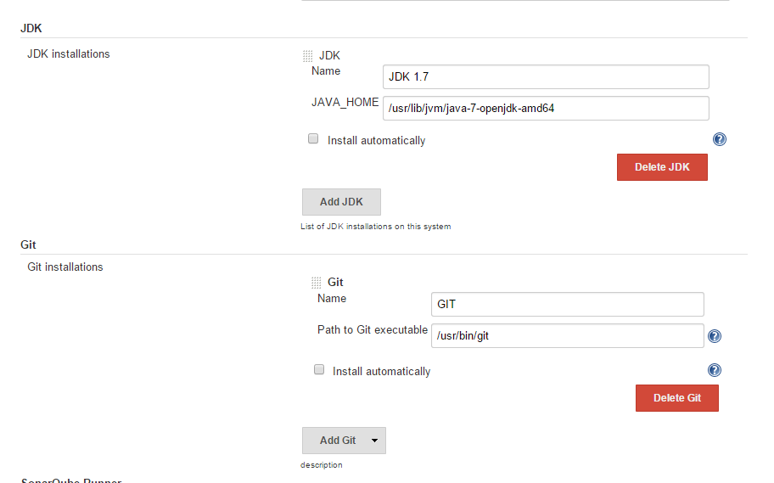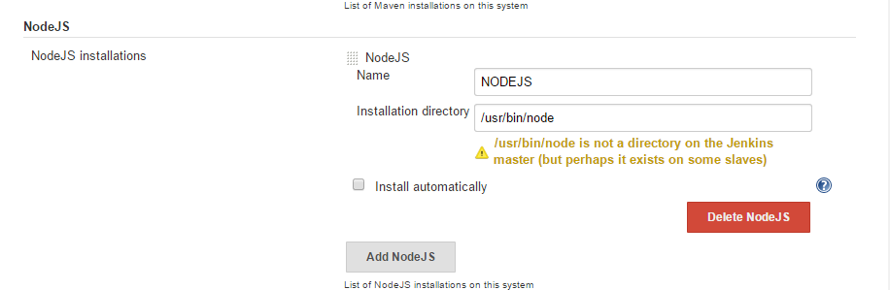

Enter the correct path to your JDK, git and Nodejs and press the *Save* button below. Jenkins can also install these for your automatically.

## **plugin installation**

Jenkins can be extended via additional plug-ins with more functionality. You can configure your plug-ins via the*Manage Jenkins* → *Manager Plugins* link.

https://assets.digitalocean.com/articles/jenkins/18.png

Plugin Installation

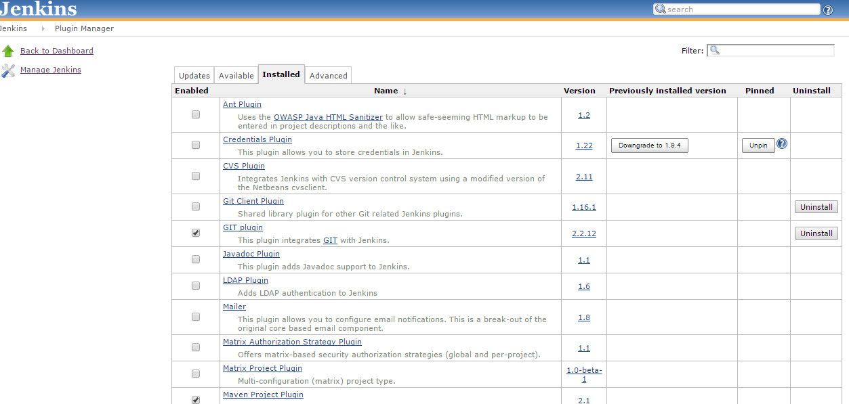

Look for the git Plugin and select it

Once your done, click on the Install without the restart button at the bottom of your screen:

https://assets.digitalocean.com/articles/jenkins/20.png

Just wait until the plugin has been installed and it's ready for use.

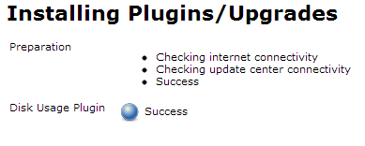

While this is a fairly simple plugin with no settings, there are plugins, such as the SSH plugin, that require some configuration after installing before you can use them properly.

## Build configuration

## **3.4.1 Adding your first job**

Now that everything is up and running, it's time to create our first job. Click the New Job link:

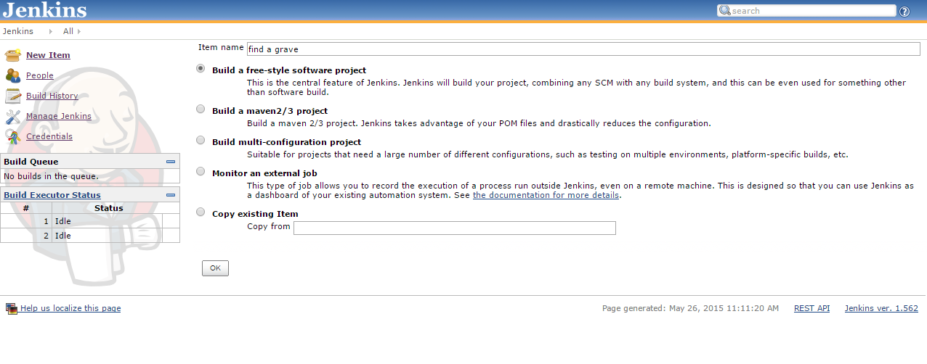

Create a freestyle project named find a grave:

Press Ok and on the next page, add a Execute shell build step:

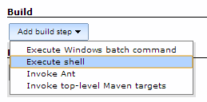

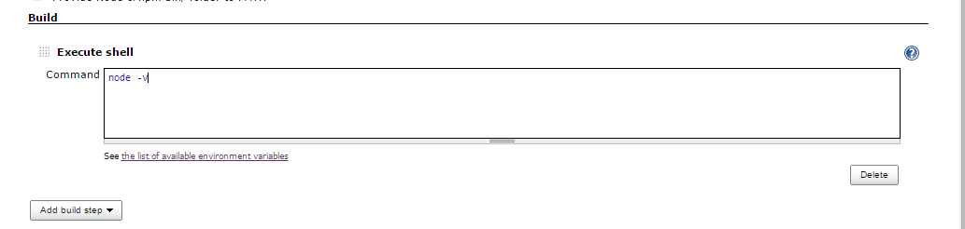

Click the save button at the bottom of the screen. Once the next page is finished, loading click the Build Now button.

https://assets.digitalocean.com/articles/jenkins/12.png

Very shortly after click, you'll see the build show up in the build history block:

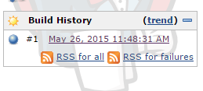

Click the blue sphere for the console output:

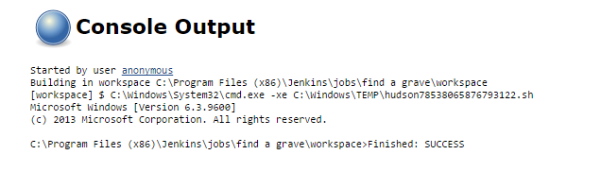

## **3.4.2 Schedule Your Job**

Jenkins can run your job on-demand or at a specific time. Now that we've set up the basic build, it's time to configure a build schedule. First, click the back to project link to return to the job overview:

https://assets.digitalocean.com/articles/jenkins/15.png

Once you're back on the overview, click the Configure button:

https://assets.digitalocean.com/articles/jenkins/16.png

This leads you to the configuration page as shown when you first set up the job. Now look for Build Triggers and check Build periodically:

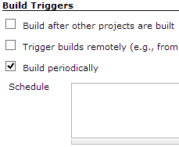

Now this input field accepts the Crontab syntax, so setting it to @hourly runs it every hour and * * * * * runs it every minute. If you want to do old school nightly builds like Firefox or WebKit, set it to @midnight to start it between midnight and 2:59 AM. We'll set it to 0 */6 * * *, starting it every 6 hours providing you a fresh build 4 times per day. When the job is saved, the scheduler will start the job at its designated times.

There are a few special extras that come with Jenkins's scheduler. Check the blue question mark at the right of the input field to find out what exactly.

## **3.4.3 Report generated by Your Job**

1.Report on Jenkins:

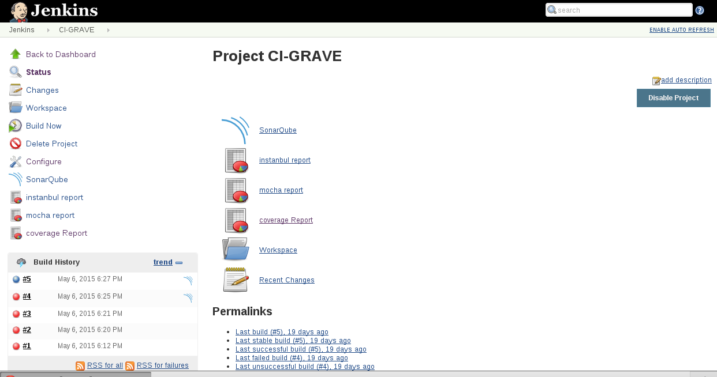

**2. Jshint Report on Jenkins :**

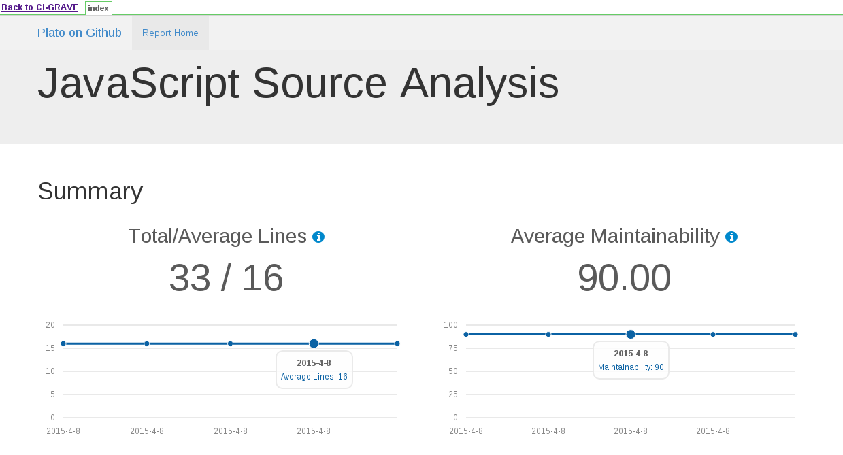\

**2. Mocha Report on Jenkins :**

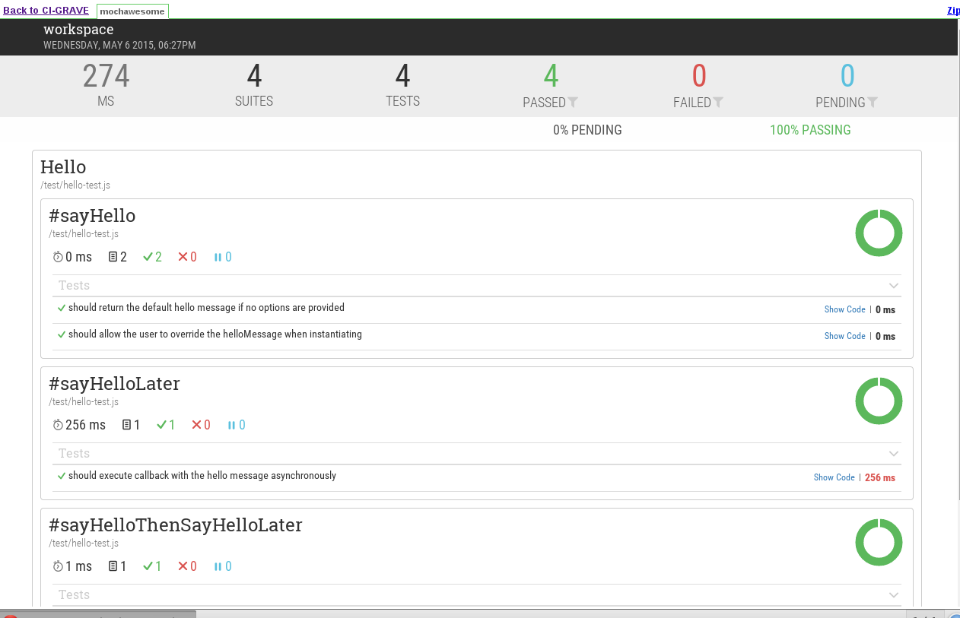

**3. Istanbul Report on Jenkins :**

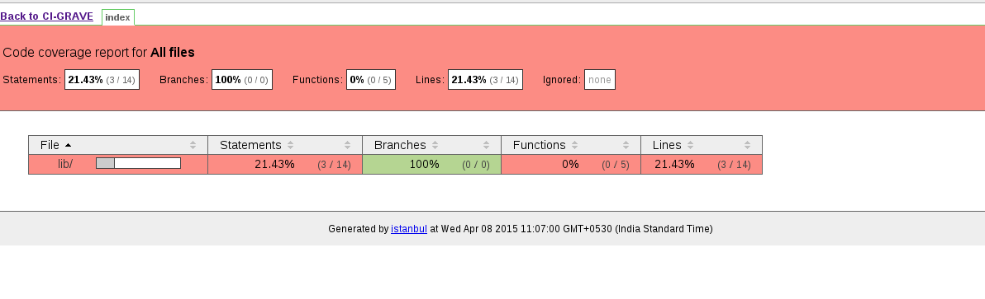

**4. Sonar Report on Jenkins :**

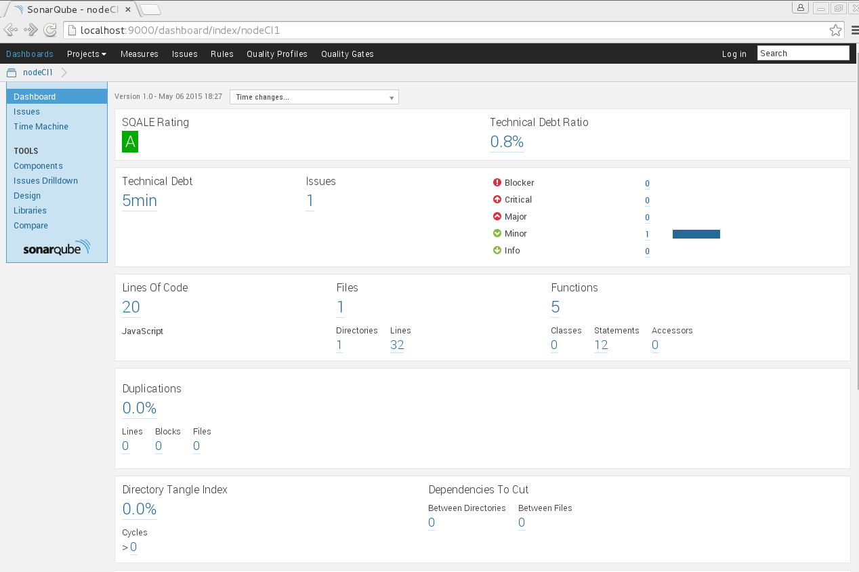

1. its 4 built-in powerful abstractions and their relationship: **Tasks** inside **Jobs** inside **Stages** inside **Pipelines**
2. the fact that some are executed in parallel (depending on agents availability) while others sequentially:
   * Multiple Pipelines run in parallel
   * Multiple Stages within a Pipeline run sequentially
   * Multiple Jobs within a Stage run in parallel
   * Multiple Tasks within a Job run sequentially

|  |
| --- |
|  |